Domayne’s Wood and Formica Oriented Bed

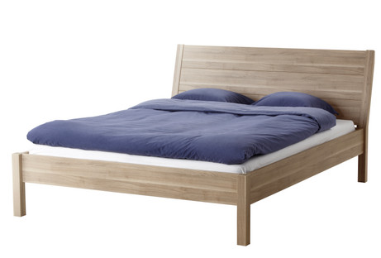

|  |
| --- |
| **DESCRIPTION** |
| Domayne introduces stylish bed with an oak veneer wood top and a rich walnut finish this set of bed is sure to create the perfect look in any home. The rich wood of the bed pairs perfectly with many different styles of decor. Perfect for your bedrooms or just an extra help in your house, your guests will love this comfortable bed. |

|  |  |  |
| --- | --- | --- |
| **Price** | **600$** | |
| **Dimensions** | **H** x **W** x **L** | **30in x 54in x 75in** |
| **Features** | **Veneer wood with water resistance nano technology plus heat resisted fiber mass which makes it perfect near beach areas** | |
| **Finished** | **Bold Lust Substitute** | |
| **Available in** | **Brown, Golden, Chrome, Black and White** | |